Project SE

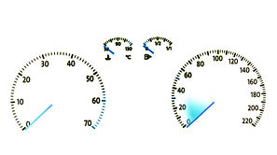Dashboard

Group 6:

Fábio Magalhães – A75030

Rui Carvalho – A76279

Index

Index 2

Problem Statement 3

Market Study 4

Constraints 5

Technical Constraints 5

Functional Requirements 5

Non-Functional Requirements 5

Hardware Specifications 6

Raspberry Pi 3 Model B 7

Display 7

Resistive Touchscreen 8

Bluetooth ELM327 OBD2 Scan Tool 9

MPU-6050 10

Tactile Buttons 10

Software Specifications 11

System Overview 12

Events 12

Use Cases 13

State Chart 13

Sequence Diagram 14

System Stack 15

Software System Overview 15

Pyramid Diagram 16

Gantt Chart 17

Problem Statement

All recent automobiles have an on-board computer, that assist the driving and the maintenance of the vehicle. It has become an accessory more and more indispensable, however it is still very expensive for the masses. Yet possible to install on older vehicles, it brings mechanical complications, and great monetary cost.

The Project’s goal is to develop an efficient, plug-n-play, inexpensive, functionality full on-board computer for the most affordable vehicles. I will be perfect companion to every road trip.

The device should get data from the car onboard diagnostic (OBD), as well as get the road slope from the gyroscope and advise the driver by showing information to the user. The information shown must be customizable by the user through button input.

Market Study

There are few similar products in the market, since most care more with audio and video display than to monitor the car and advise the driver.

X50 Plus OBD

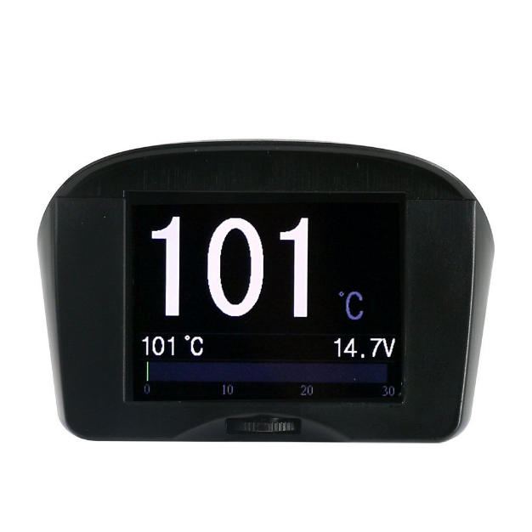 X50 Plus OBD mini car trip computer is a small car instrument with powerful functions, which is especially suitable for vehicles without a tachometer, an engine temperature gauge and fuel consumption display functions.

X50 Plus can also display and monitor vehicle battery voltage, generator charging voltage, offering vehicle over speed alarm, high engine temperature alarm and monitoring and other functions. It even can read vehicle data streams, scan engine fault codes and offer fault code clearing functions. Available at a reasonable price.

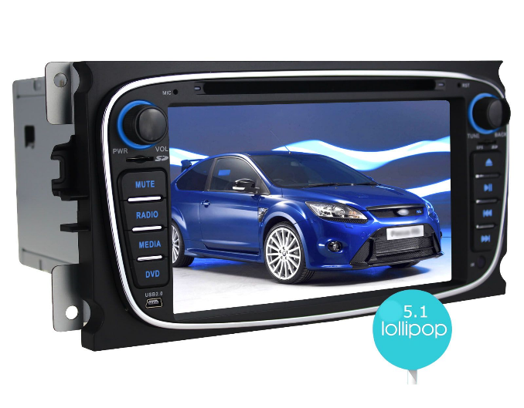 JOYING

Joying is a Professional high quality Android auto radio Head Unit In dash car GPS navigation supplier, which focus on entertainment while on trip, with network, audio, video, Bluetooth and GPS capability, instead of focusing on car monitor. Which inflates the price above a reasonable value.

­

Constraints

* Budget must be minimal.
* Project developed by a team of two.
* Pretty design

Technical Constraints

* Raspeberry Pi 3 Model B
* Buildroot
* Pthreads
* C/C++ programming language
* User Implemented Device Driver

Functional Requirements

* Get car information through OBD port
* Show data on screen
* Alert the user for malfunctions
* Calculate road slope
* Warn bad driver behaviour

Non-Functional Requirements

* Low Cost and low power.
* User-friendly interface.
* Plug’n’play
* Low latency.
* Soft Real-time

Hardware Specifications

* Raspberry Pi 3
  + BCM2837 Chip 64 bit ARMv8 Cortex A53 Quad Core
  + 1GB RAM
  + Wireless LAN
  + Bluetooth 4.1
  + 4 USB Ports
  + 40 GPIO Pins
  + HDMI Port
  + Ethernet Port
  + Micro SD Card Slot
* TFT with Touchscreen
  + ILI9488 Display Driver
  + 320x480 Resolution
  + Resistive Touchscreen
* OBD module with Bluetooth
  + ELM327
  + OBDII interface
* Accelerometer and Gyroscope
  + MPU-6050
  + Six Axis
  + I2C Communication
* Tactile Buttons

## Raspberry Pi 3 Model B

The Raspberry Pi 3 is the third-generation Raspberry Pi.

* Quad Core 1.2GHz Broadcom BCM2837 64bit CPU
* 1GB RAM
* BCM43438 wireless LAN and Bluetooth Low Energy (BLE) on board
* 40-pin extended GPIO
* 4 USB 2 ports
* 4 Pole stereo output and composite video port
* Full size HDMI
* CSI camera port for connecting a Raspberry Pi camera
* DSI display port for connecting a Raspberry Pi touchscree n display
* Micro SD port for loading your operating system and storing data
* Micro USB power source up to 2.5A

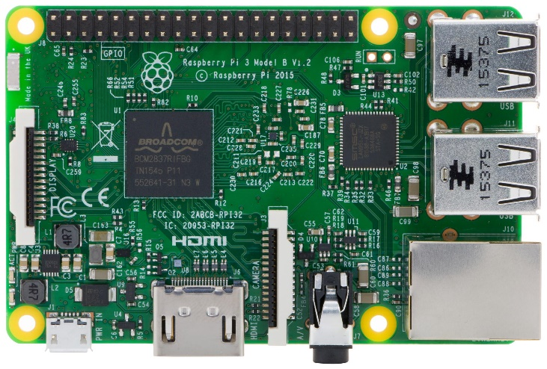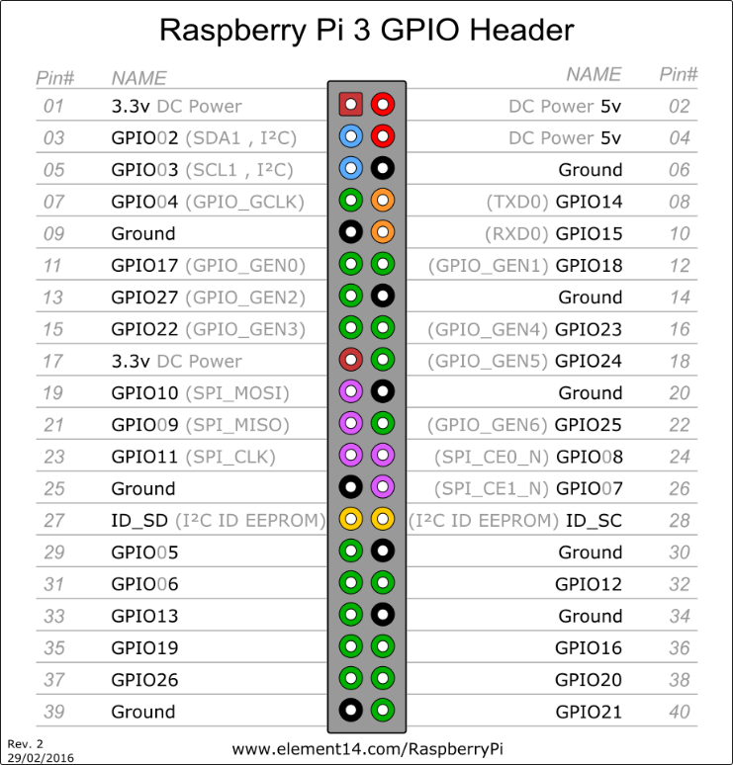

## Display

ILI9488 Display Driver, SPI Compatible

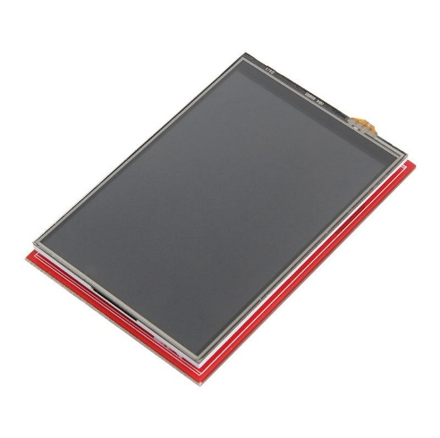Specifications:

|  |  |
| --- | --- |
| Resolution | 320x480 |
| Frame Memory | 345 kbytes |
| Input Image | 24 bits |
| IO VCC | 1.65 – 3.3 V |
| Temperature | -40 ~ +85 °C |

Interface:

|  |  |  |
| --- | --- | --- |
|  | Pin Name | Pin Function |
| SCK | PA5 | SPI1_SCK |
| MISO | PA6 | SPI1_MISO |
| MOSI | PA7 | SPI1_MOSI |

Test Cases:

|  |  |  |
| --- | --- | --- |
|  | Expected Output | Real output |
|  |  |  |
|  |  |  |
|  |  |  |
|  |  |  |

## Resistive Touchscreen

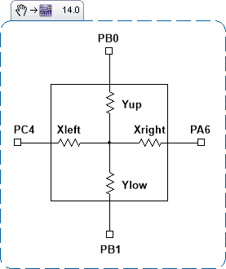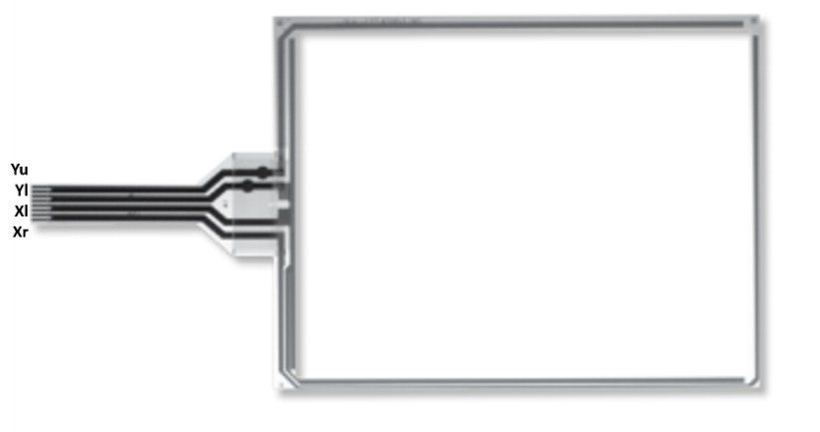

Specifications:

Interface:

|  |  |  |
| --- | --- | --- |
|  | Pin Name | Pin Function |
| Yup | PB0 | ADC12_IN8, GPIO IN/OUT |
| Ylow | PB1 | ADC12_IN9, GPIO IN/OUT |
| Xleft | PE7 |  |
| Xright | PE8 |  |

Test Cases:

|  |  |  |
| --- | --- | --- |
| Touch | Expected Output (X,Y) | Real output (X,Y) |
| Right Top Corner |  |  |
| Right Bottom Corner |  |  |
| Left Top Corner |  |  |
| Left Bottom Corner |  |  |
| No Touch | 0,0 |  |

## Bluetooth ELM327 OBD2 Scan Tool

Read diagnostic trouble codes, both generic and ma nufacturer-specific, and display their meaning. Class 2 Bluetooth transmission with Adaptive Power Control.

Specifications:

|  |  |
| --- | --- |
| Suported Protocols | J1850 PWM (Ford),  J1850 VPW (GM)  ISO9141-2 (Asia, Europe, Chrysler)  ISO14230-4 (Keyword Protocol)  ISO15765-4 (CAN) |
| Output Protocol: | RS232 to Bluetooth |
| Bluetooth Range | 5 ~ 15 m |
| Baud Rate | 9600 / 38400 |
| Operating Voltage | 12 / 24 V |
| Idle Current | 45 mA |
| Operating Temperature | -20º ~ 55º C |
| Operating Humidity | 10 ~ 85% |

Interface:

The device connects with the Raspberry Pi board through Bluetooth, using the onboard Bluetooth Module.

Test Cases:

|  |  |  |  |
| --- | --- | --- | --- |
| Send Command | Expected Output | Real output | Comment |
| AT Z | “ELM327 v1.x” |  | Reset Module |
| AT RV | “12.5V” |  | System Voltage |
| AT SP0 | “OK” |  | Find Protocol |

## https://nexiot.com/wp-content/uploads/2017/08/sku_154602_2.jpgMPU-6050

Contains a MEMS accelerometer and a MEMS gyro in a single chip. It is very accurate, as it contains 16-bits analog to digital conversion hardware for each channel. Therefore it captures the x, y, and z channel at the same time. The sensor uses the I2C-bus to interface with a microcontroller.

Specifications:

|  |  |
| --- | --- |
| VDD | 2.375 ~ 3.46V |
| VLOGIC | 1.71V ~ VDD |
| Serial Interface | I2C |
| Gyroscope | X,Y, and Z axis |
| Range | ±250, ±500, ±1000, ±2000 °/sec |
| Operating Current | 3.6 mA |
| Standby Current | 5µA |
| I2C Operating Frequency | 100 ~ 400 kHz |

Interface:

|  |  |  |
| --- | --- | --- |
|  | Pin Name | Pin Function |
| SCL | GPIO02 | SCL |
| SDA | GPIO03 | SDA |

Test Cases:

|  |  |  |  |
| --- | --- | --- | --- |
| Send Command | Expected Output | Real output | Comment |
| 0x75 | 0x34 |  | Device Adress |

## Tactile Buttons

Generic Tactile Push Buttons

Specifications:

|  |  |
| --- | --- |
| Size (L*W*H) | 6*6*5 mm |
| Rated Voltage | 12 V |
| Rated Current | 50 mA |
| Contact Resistance | ≤ 0.03 Ω |
| Insulation Resistance | ≥ 100 MΩ |

Interface:

|  |  |  |
| --- | --- | --- |
|  | Pin Name | Pin Function |
| UP_BT | GPIO16 | Input |
| DOWN_BT | GPIO20 | Input |
| OK_BT | GPIO21 | Input |

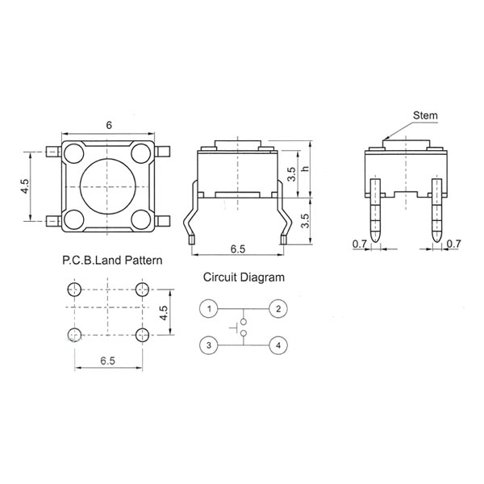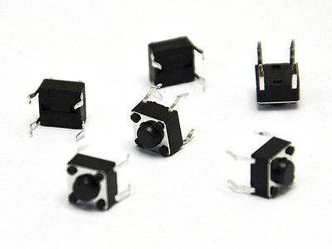

Software Specifications

* Embedded Linux
* C/C++ Language
* Buildroot

System Overview

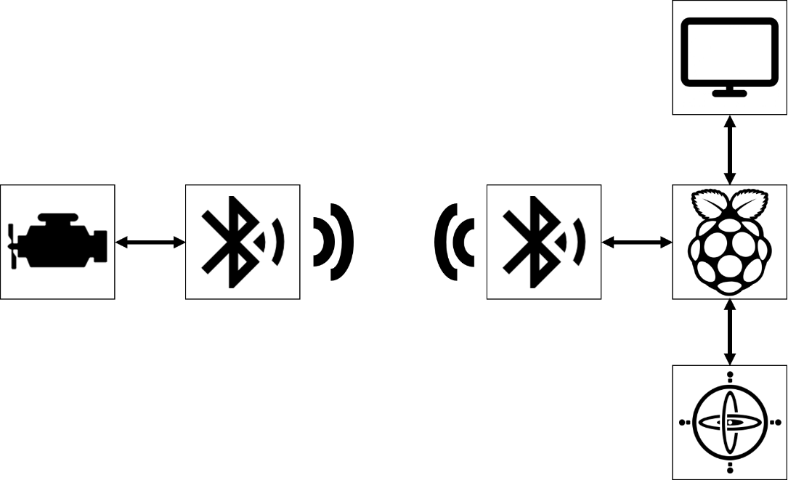

Events

|  |  |  |
| --- | --- | --- |
| Event | System Response | Source |
| On/Off | Turn System On/Off | User |
| Read OBD | Reads OBD data | Local Sys |
| Read Gyro | Reads gyroscope data | Local Sys |
| Display | Changes display | Local Sys |
| Button Click | Reads buttons states | User |

Use Cases

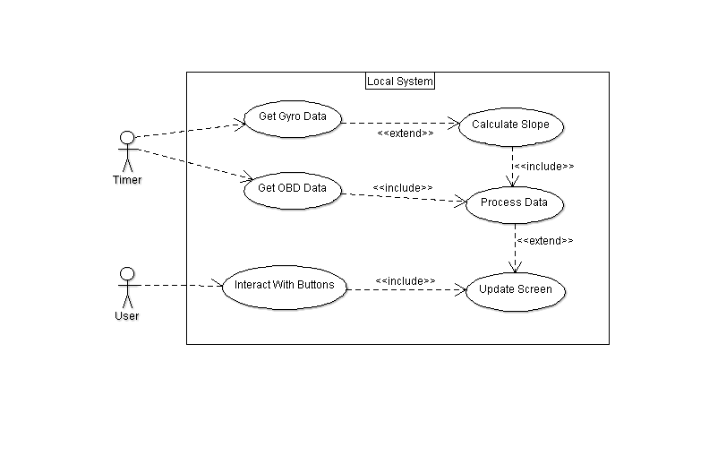

State Chart

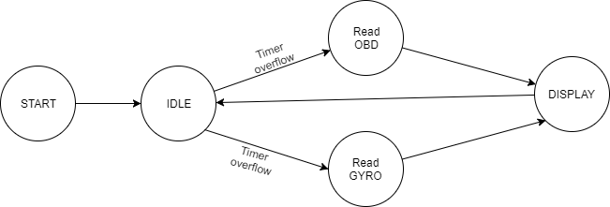

Local and Remote System

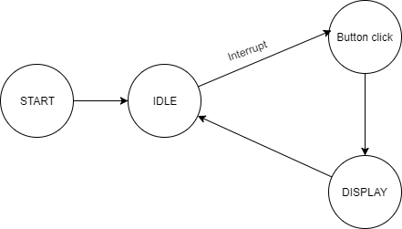

User Interface

Sequence Diagram

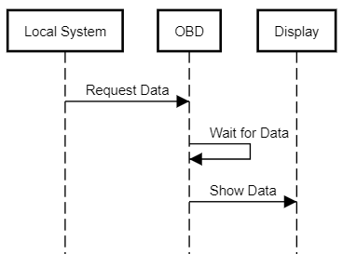

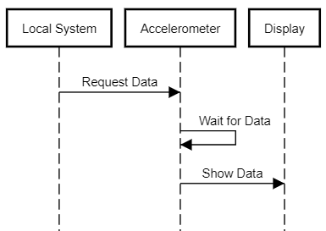

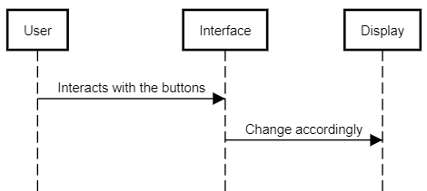

System Stack

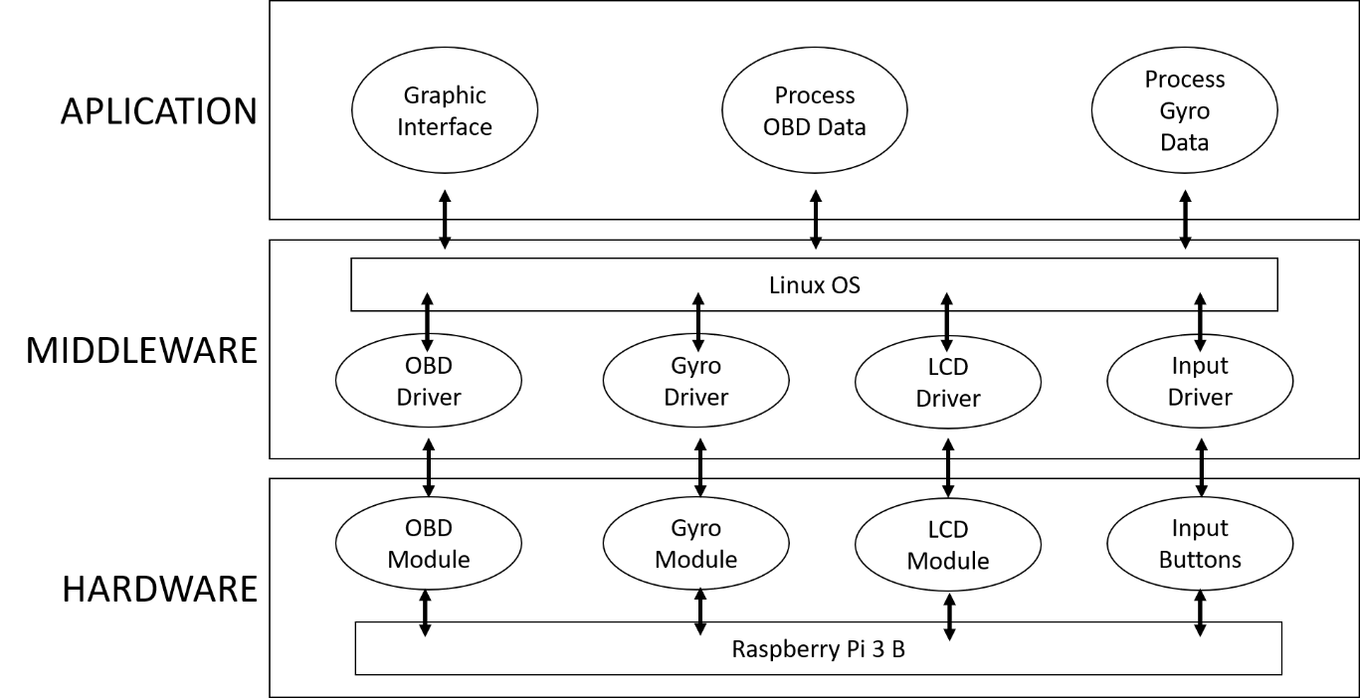

Software System Overview

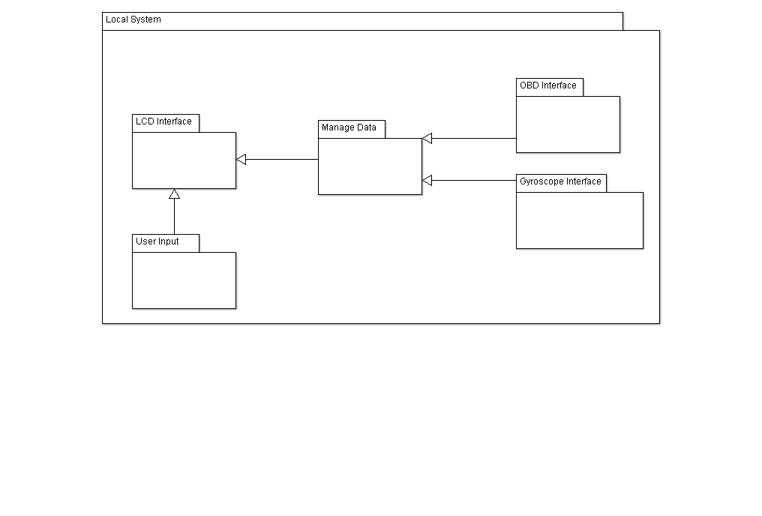

Pyramid Diagram

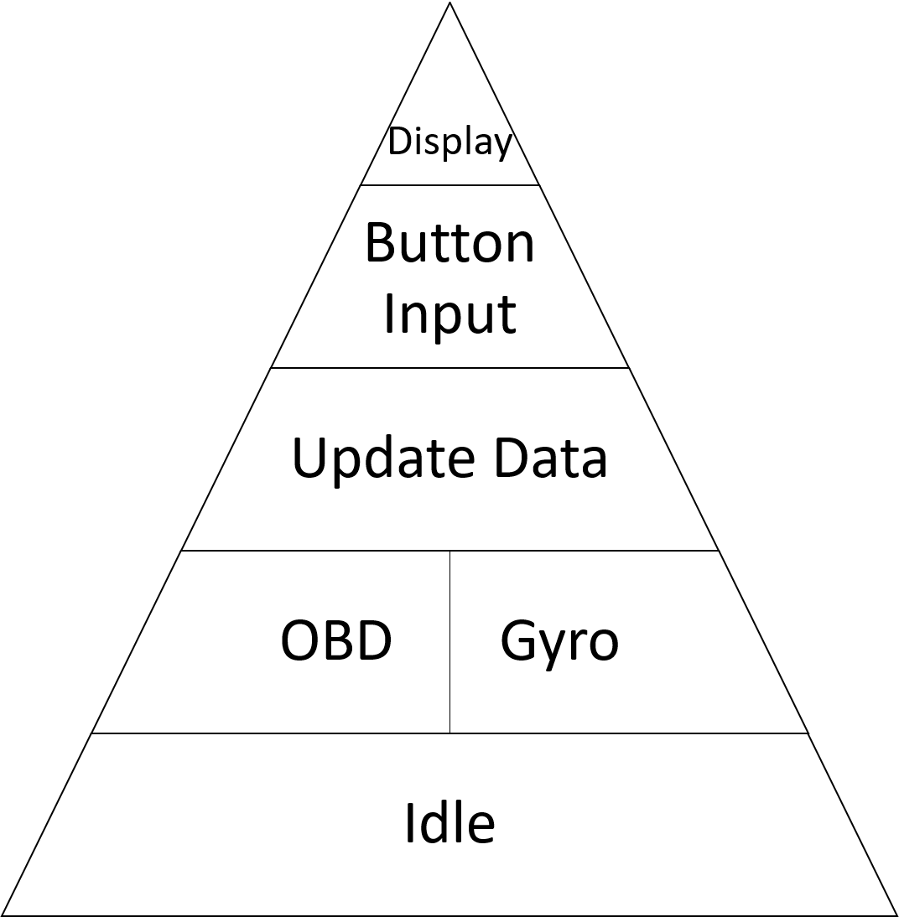

Gantt Chart

|  |  |
| --- | --- |
|  | Fábio Magalhães |
|  | Rui Carvalho |

